K-Nearest Neighbors

Closest relation And far relation

Maths: Distance between two points

$euclidian distance metric$

$\left(x_{1},y_{1}\right) \left(x_{2},y_{2}\right)=\sqrt{{\left(x_{2}-x_{1}\right)}^{2}+{\left(y_{2}-y_{1}\right)}^{2} }$

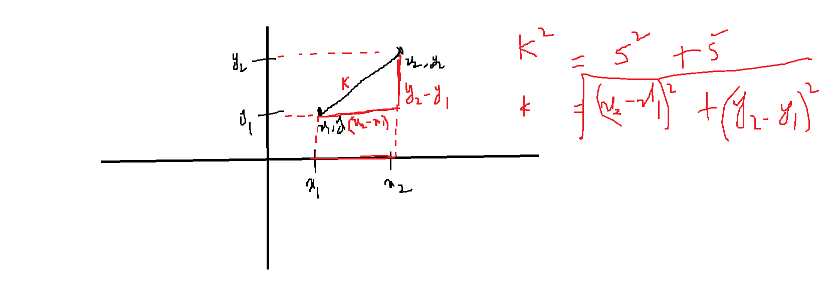

| X1 | X2 | y |
| --- | --- | --- |
| 7 | 7 | Bad |
| 7 | 4 | Bad |
| 3 | 4 | Good |
| 1 | 4 | Good |

Question:

If new tuple X1=3, and X2=7 what is Y?

Step-1: Calculate distance between each observation

$\left(7,7\right) \left(3,7\right)=\sqrt{{\left(3-7\right)}^{2}+{\left(7-7\right)}^{2} }=\sqrt{16 }$

$\left(7,4\right) \left(3,7\right)=\sqrt{{\left(3-7\right)}^{2}+{\left(7-4\right)}^{2} }$ = $\sqrt{25 }$

$\left(3,4\right) \left(3,7\right)=\sqrt{{\left(3-3\right)}^{2}+{\left(7-4\right)}^{2}}=\sqrt{9 }$

$\left(1,4\right) \left(3,7\right)=\sqrt{{\left(3-1\right)}^{2}+{\left(7-4\right)}^{2} }=\sqrt{13}$

| X1 | X2 | y | d |
| --- | --- | --- | --- |
| 7 | 7 | Bad | $\sqrt{16 }$ |
| 7 | 4 | Bad | $\sqrt{25 }$ |
| 3 | 4 | Good | $\sqrt{9 }$ |
| 1 | 4 | Good | $\sqrt{13}$ |

Step-2: Provide the ranking

| X1 | X2 | y | d | Rank |
| --- | --- | --- | --- | --- |
| 7 | 7 | Bad | $\sqrt{16 }$ | 3 |
| 7 | 4 | Bad | $\sqrt{25 }$ | 4 |
| 3 | 4 | Good | $\sqrt{9 }$ | 1 |
| 1 | 4 | Good | $\sqrt{13}$ | 2 |

Step-3: choose your neighbors k=3

| X1 | X2 | y | d | Rank | Neighbor or not |
| --- | --- | --- | --- | --- | --- |
| 7 | 7 | Bad | $\sqrt{16 }$ | 3 | Yes |
| 7 | 4 | Bad | $\sqrt{25 }$ | 4 | No |
| 3 | 4 | Good | $\sqrt{9 }$ | 1 | Yes |
| 1 | 4 | Good | $\sqrt{13}$ | 2 | Yes |

Step-4: for only those are neighbors write the original label

| X1 | X2 | y | d | Rank | Neighbor or not | Original |
| --- | --- | --- | --- | --- | --- | --- |
| 7 | 7 | Bad | $\sqrt{16 }$ | 3 | Yes | Bad |
| 7 | 4 | Bad | $\sqrt{25 }$ | 4 | No | ------ |
| 3 | 4 | Good | $\sqrt{9 }$ | 1 | Yes | Good |
| 1 | 4 | Good | $\sqrt{13}$ | 2 | Yes | Good |

Bad Good Good

3 member committee : majority of voting

Conclusion: Good

$\left(3,7\right) will be under good$

$when will the model overfit$

$k=2-1=1$

$how to choose k:$

$K is always an odd number$

$k= \sqrt{number of observation}=\sqrt{4}=2-1 or 2+1$